AI ASSISTED CODING
Lab 17 – AI for Data Processing: Data Cleaning and Preprocessing Scripts
Name: M.Sai Samhitha
Roll no: 2503A51L52
Batch: 25BTCAICSB20

Task 1 – Employee Data Preprocessing Task:
Use AI to generate a Python script for cleaning an employee dataset. Instructions:
- Handle missing values in columns (salary, department, joining date).
- Convert the "joining date" column into proper datetime format.
- Standardize department names (e.g., "HR", "hr", "Human Resources" → "HR").
- Encode categorical variables (department, job role).

Prompt:
Generate a Python script using Pandas to clean an employee dataset by handling missing values, formatting dates, standardizing department names, and encoding categorical columns.
Code Generated:

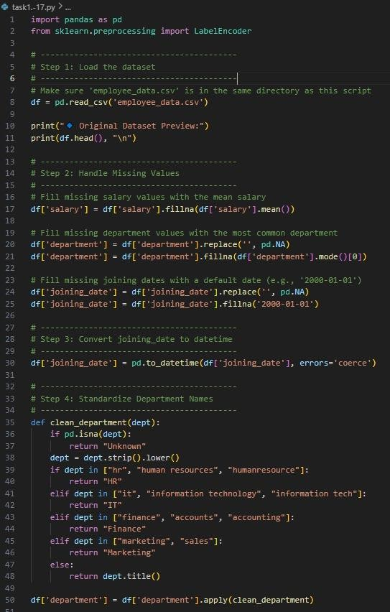

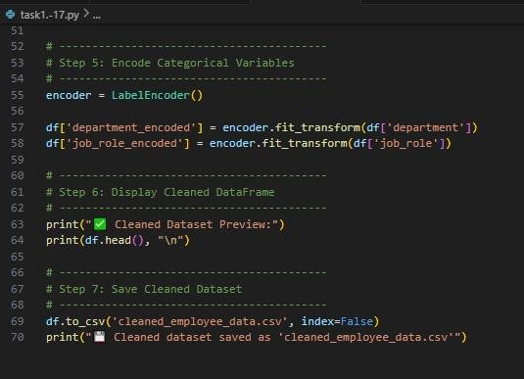
Output:

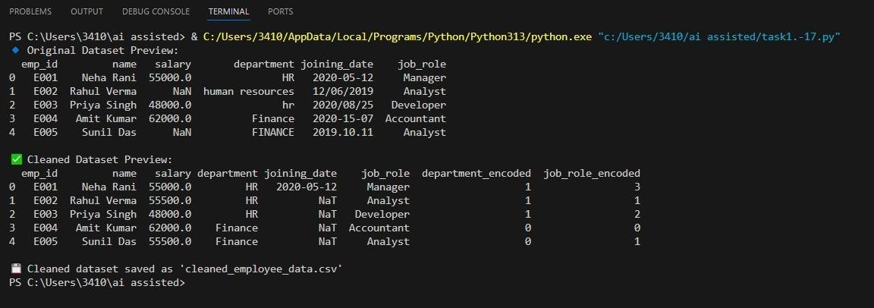
Observation:
The Python script successfully cleans and preprocesses the employee dataset.
  - Missing salary values are filled with the mean.
  - Missing department entries are replaced with the most common department.
  - Missing joining dates are set to a default date (2000-01-01).
  - Department names are standardized (e.g., HR, IT, Finance, Marketing).
  - Categorical columns like department and job_role are encoded using LabelEncoder.
  - The cleaned data is saved as cleaned_employee_data.csv for further analysis.

Task 2 – Sales Transaction Data Preprocessing Task:
Use AI to generate a script for preprocessing a sales transaction dataset. Instructions:
- Convert transaction dates to proper datetime format.
- Create a new column for “Month-Year” from the transaction date.
- Remove rows with negative or zero transaction amounts.
- Normalize the "transaction amount" column using Min-Max scaling.
Expected Output:
- A pre-processed Data Frame with valid dates, normalized amounts, and no invalid records.

Prompt:
Use Python and Pandas to preprocess a sales transaction dataset by fixing date formats, removing invalid transactions, deriving Month-Year, and normalizing amounts.

Code Generated:
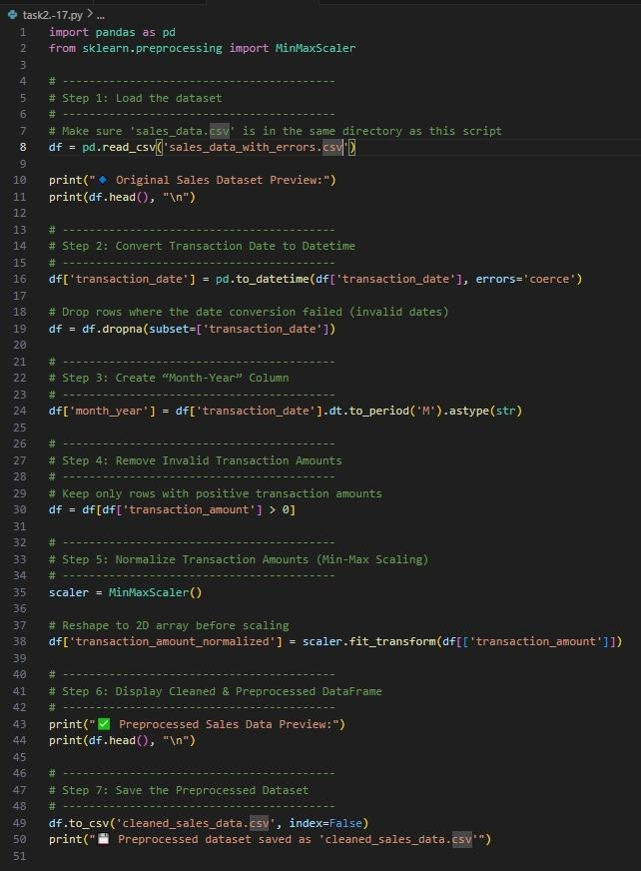

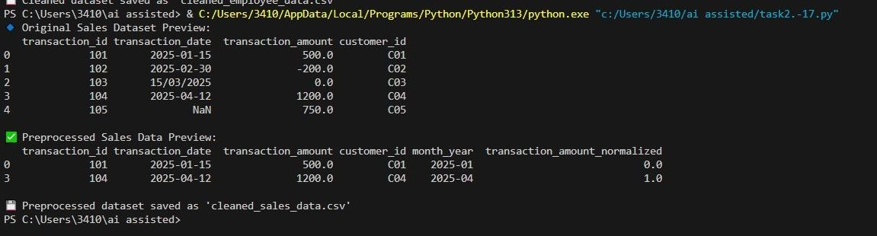

Observation:
The Python script cleans and preprocesses the sales dataset effectively.
  - Invalid dates are converted and dropped if incorrect.
  - A new Month-Year column is created for time-based analysis.
  - Negative or zero transaction amounts are removed.
  - Transaction amounts are normalized using Min-Max scaling.
  - The final cleaned dataset is saved as cleaned_sales_data.csv for further use.

Task 3 – Healthcare Patient Records Cleaning Task:
Use AI to generate a script for cleaning healthcare patient records. Instructions:
- Fill missing values in numeric columns (e.g., blood pressure, heartrate) with column mean.
- Standardize units (convert height from cm to meters).
- Correct inconsistent categorical labels (e.g., "M", "Male", "male"
→ "Male").
- Drop irrelevant columns such as patient_id after cleaning. Expected Output:
- A cleaned healthcare dataset suitable for ML model training.

Prompt:

Write a Python script to clean healthcare patient data by filling missing numeric values with means, standardizing units, correcting categorical labels, and removing irrelevant columns.

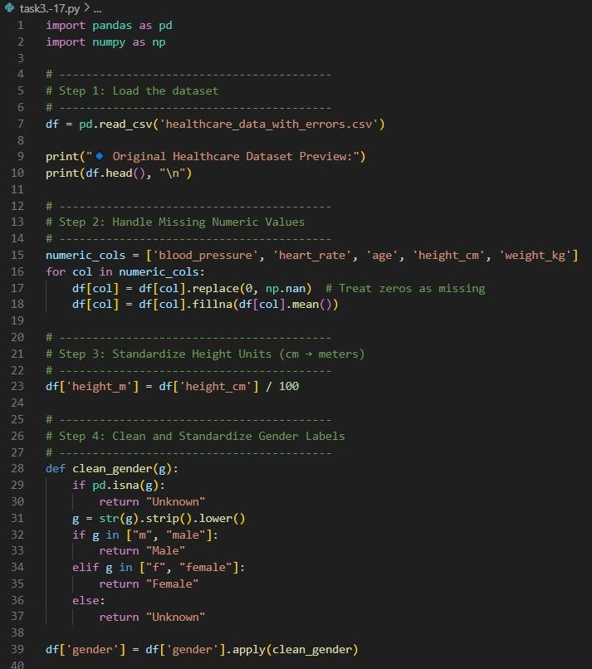

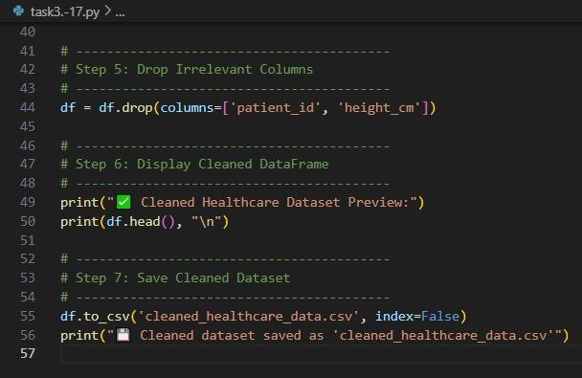

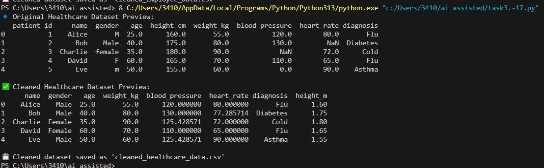

Observation:
The script successfully cleans and standardizes the healthcare dataset.

  - Missing or zero numeric values are replaced with column means.

  - Height is converted from centimetres to meters.

  - Gender labels are standardized (Male, Female, Unknown).

  - Irrelevant columns like patient_id and height are removed.

  - The cleaned data is saved as cleaned_healthcare_data.csv for further analysis.

Task 4 – Social Media Sentiment Dataset Preparation Task:
Use AI to write a script to preprocess a social media text dataset. Instructions:
- Remove special characters, URLs, and emojis from text.
- Convert all text to lowercase.
- Tokenize and remove stopwords.
- Apply lemmatization for standardizing words. Expected Output:
- A processed dataset with clean text, ready for NLP sentiment analysis.

Prompt:

Create a Python NLP preprocessing script to clean social media text by removing noise, converting to lowercase, tokenizing, removing stopwords, and lemmatizing

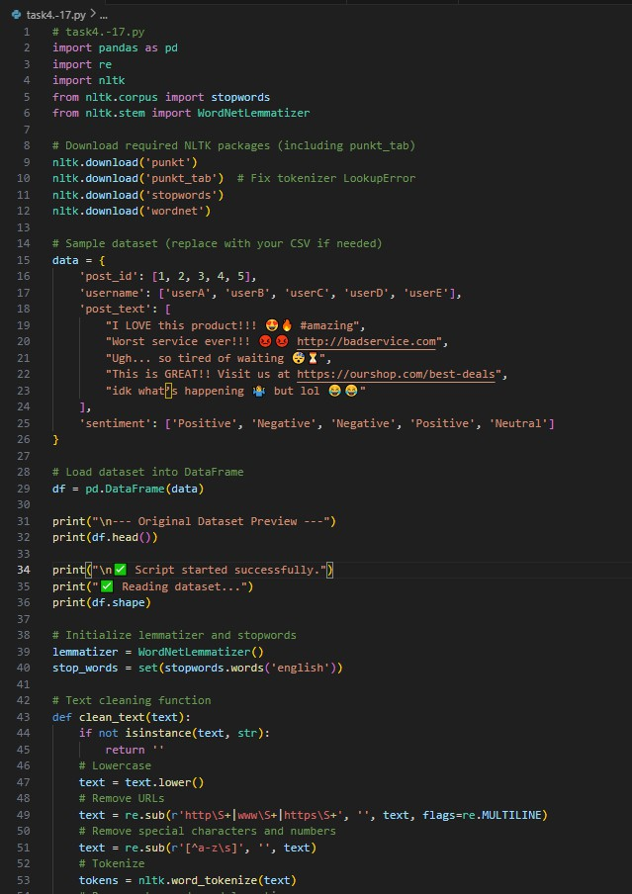

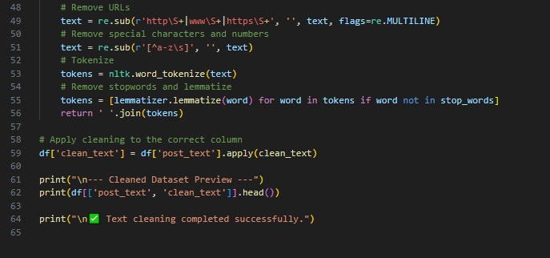

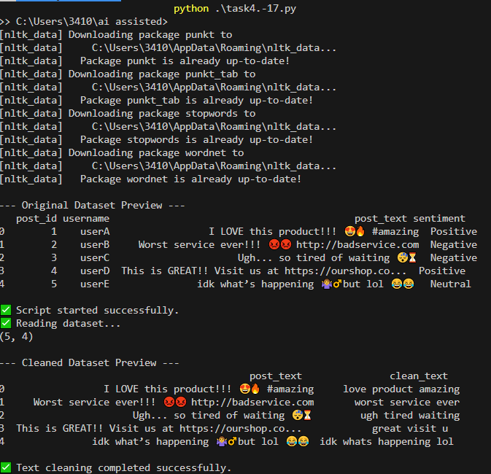

Observation:

  - The script successfully reads the dataset and applies text preprocessing on the post_text column.
  - Preprocessing steps include lowercasing, URL removal, special character removal, tokenization, stopword removal, and lemmatization.
  - The resulting clean_text column contains simplified, normalized text ready for further analysis (e.g., sentiment analysis or modeling).
  - Original text is preserved in post_text for reference.

Task 5 – Financial Dataset Feature Engineering Task:
Use AI to create a preprocessing script for a financial dataset. Instructions:
- Handle missing values in stock price and volume.
- Create new features such as moving average (7-day, 30-day).

- Normalize continuous variables using StandardScaler.
- Encode categorical columns (sector, company_name). Expected Output:
- A feature-engineered Data Frame with new indicators and normalized values for ML tasks
Prompt: Generate a Python script to preprocess and engineer features for a financial dataset by handling missing values, creating moving averages, normalizing numeric columns, and encoding categorical data.

Code Generated:
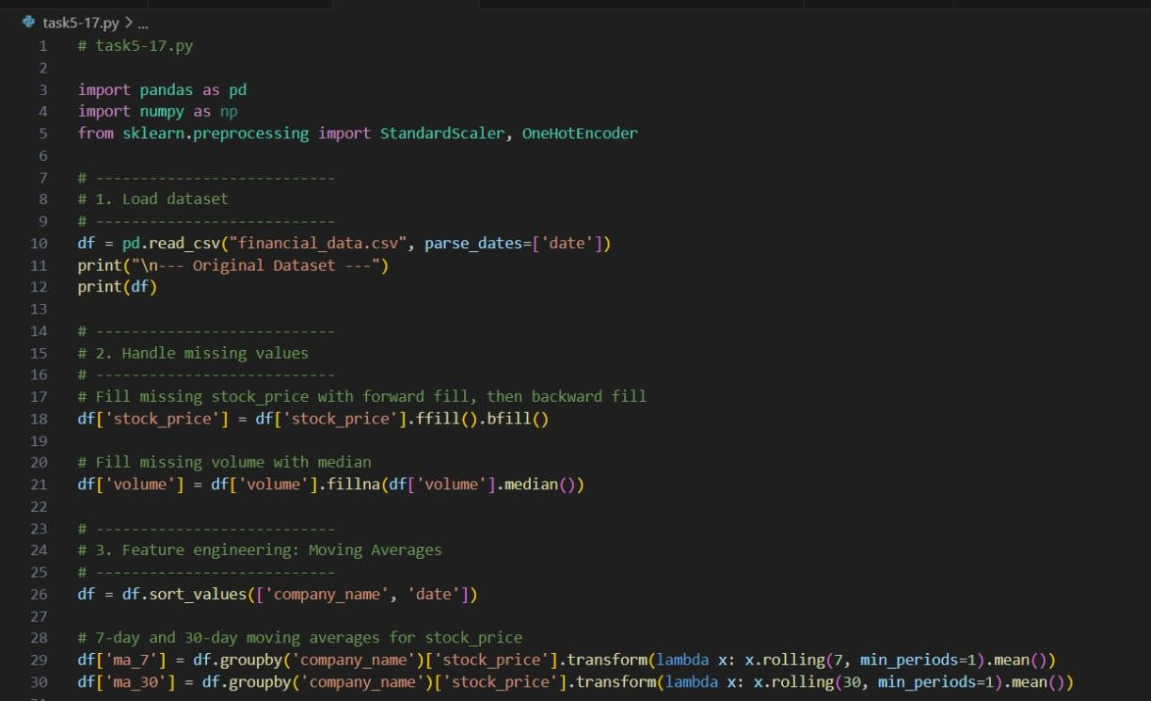
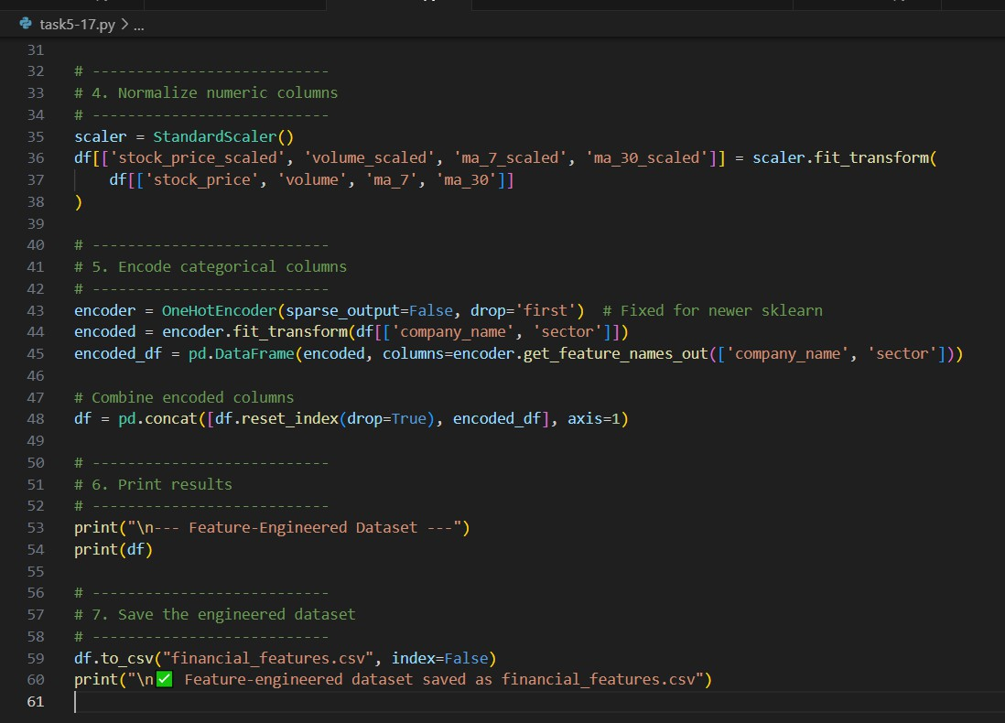

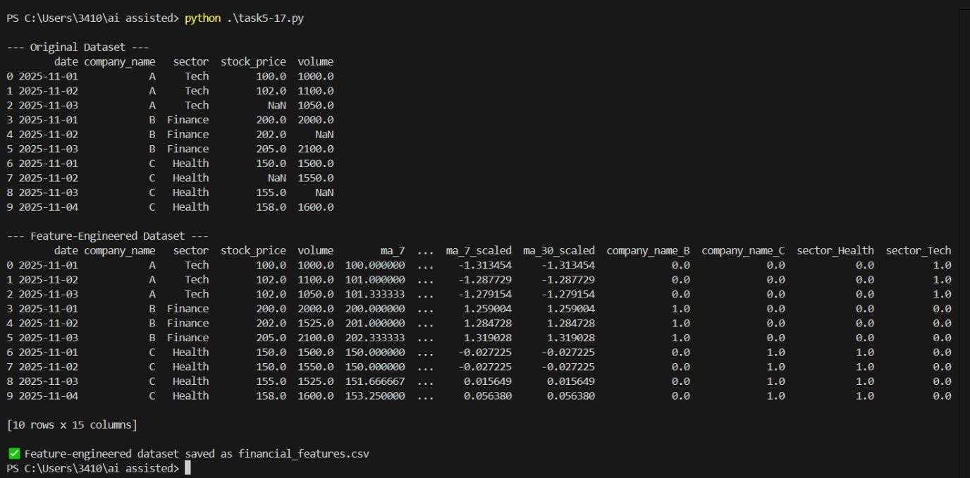

Observation:

  - Missing values in stock_price were filled using forward/backward fill; missing volume was replaced with the median.
  - 7-day and 30-day moving averages for stock price were successfully created per company.
  - Continuous variables (stock_price, volume, ma_7, ma_30) were normalized using StandardScaler.
  - Categorical columns (company_name, sector) were one-hot encoded.
  - The final dataset is ready for machine learning tasks and saved as financial_features.csv.

